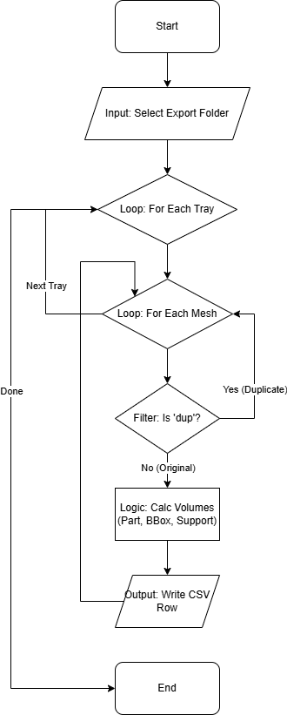
CSV Export Script (MJ)
Script Name: CSV_Export_MJ.lua

Functionality
This script automates the extraction of part metadata for project tracking. It cycles through all active trays and meshes to generate a report containing:
- Tray Name
- Mesh Name
- Part Volume (Single and Total)
- Bounding Box Volume
- Support Volume (Single and Total)
- Tray Build Time (Placeholder for manual entry)
Logic Flow: The script iterates through every mesh in every tray. It calculates volumes and dimensions, filters out duplicate parts (names containing "_dup"), and compiles the data into a CSV file. If the standard file write operation fails, it attempts to use the system log as a fallback.

User Guide (Quick Start)
- Open the Netfabb project containing the parts you wish to export.
- Run the script CSV_Export_MJ.
- A dialog will appear asking for the Export Folder. Select the directory where you want the CSV file saved.
- The script will process all trays. A "Success" popup will appear when finished.
- Important: Open the generated CSV file. The "Tray Build Time" column will show "nil". You must manually input the estimated build time from the machine's official speed review or print software.

Code Maintenance & Technical Notes
Build Time Limitation: Lua scripts in this environment cannot access the internal JSON-based build time estimates (Reference: Autodesk Help GUID-5830CB69). The script intentionally outputs "nil" for this field to prompt manual entry.
Duplicate Filtering: The script assumes that any mesh with "_dup" (case-insensitive) in its name is a copy generated for arrangement and should be excluded from the unique part list. If naming conventions change, update the filtering logic in the loop.
File Writing Fallback: The standard io library is often restricted. The script includes a fallback to system:logtofile(). If this fallback is triggered, the CSV may include timestamp prefixes on every line, which might need cleaning in Excel.

